**Chapter 3 Task Manager**

Task Manager enables you to manage and keep track of all your office tasks, court matters, appointments and messages.

*In this Chapter*

**3.1 Calendar**

**3.2 New Task To-Do**

**3.3 Manage Task To-Do**

**3.4 New Court Matter**

**3.5 Manage Court Matter**

**3.6 New Appointment**

**3.7 Manage Appointment**

**3.8 Reminder List**

**3.1 Calendar**

Legal Manager Calendar is fully integrated with task-to-do, court matter, and appointment features. You can filter the task by task-to-do, court matter, appointment or file no. Besides, you can view the calendar with the format day, week or timeline at the selection right hand side.

* To open Calendar, on the **SmartLeg@l** navigation, click **Task Manager** and go to **Calendar** then you may view your tasks with calendar.

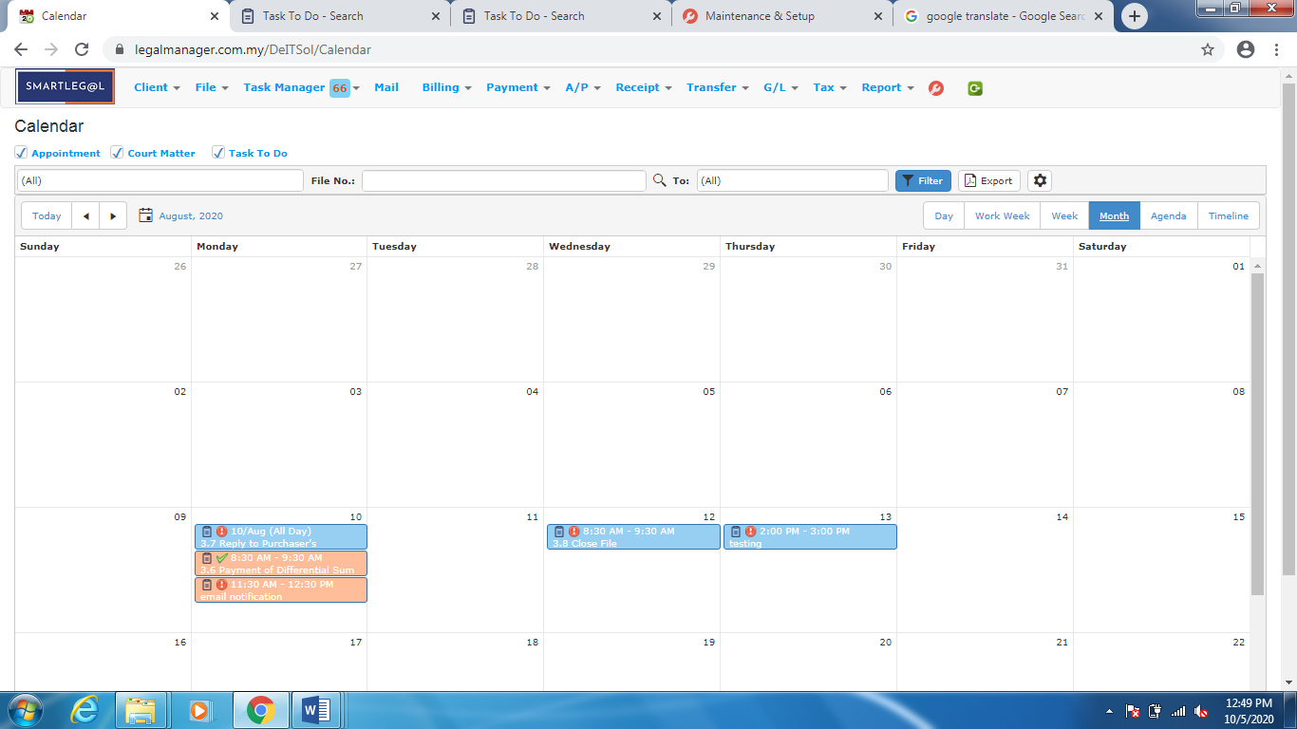

Figure: Calendar

* Right click function provides add, edit, delete, view and save as function.
* A helpful tool tip will show up as shown in ‘figure: Calendar Tool Tip’, when your mouse pint to a particular task.

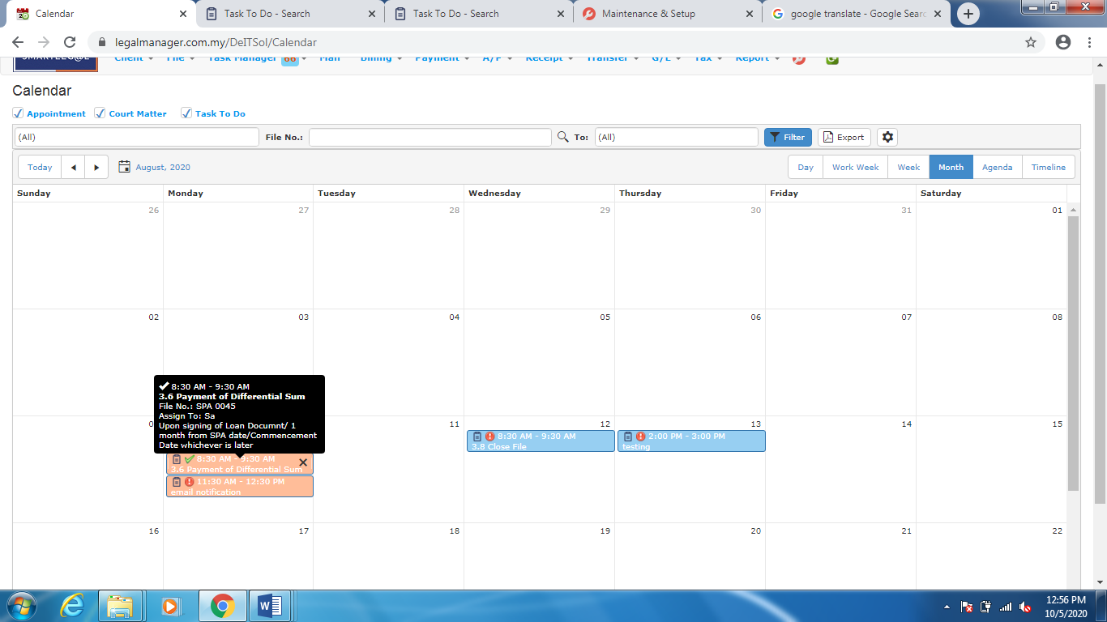

Figure: Calendar Tool Tip

**3.2 New Task To-Do**

Users and managers can create and assign task to-do, assign priority and reference them to file. Users can copy task to court matter. Retrieval of the task from the menu bar is easy.

* To open New Task To-Do, on the **SmartLeg@l** navigation, click **Task Manager** and go to **New Task To Do** then click the tab you want to type in information.
  + Task To-Do form will show up, as shown in ‘Figure: New Task To Do’.
  + In the Task Name box, type a task name.
  + Complete all other information.
  + You can assign task to a user.
  + You can CC task to more than one user.
  + Due date is optional and must be greater than or equal to start date.
  + Click ‘**Save**’.

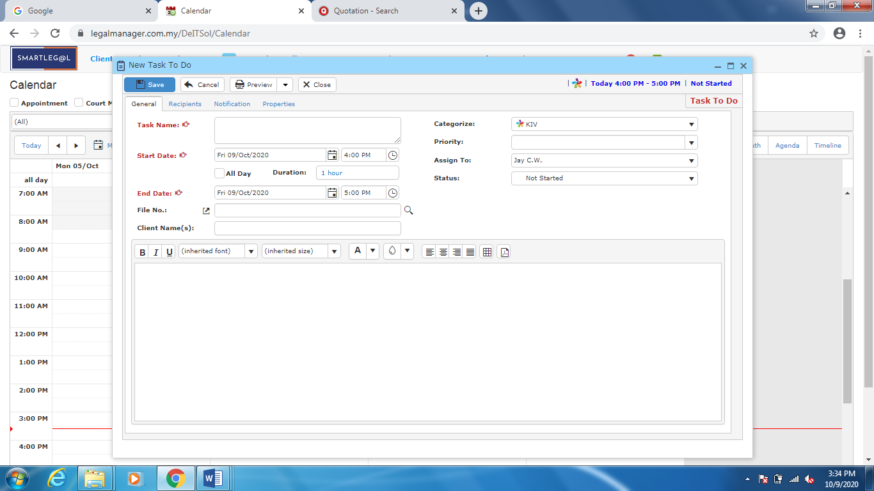

Figure: New Task To Do

* + You can Add or Remove Recipient as Figure: New Task To Do – Recipient, Add Recipient
  + You can also choose to allow recipient to view or modify

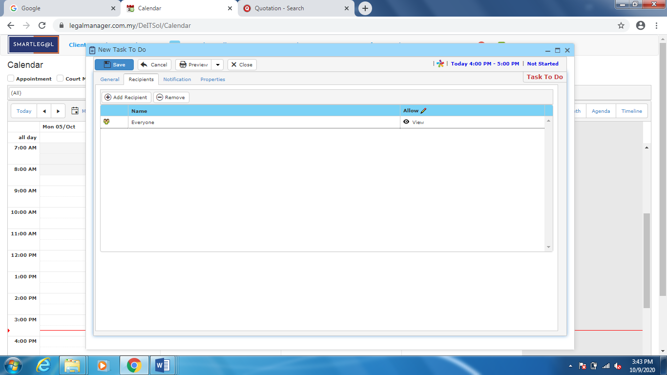

Figure: New Task To Do – Recipients

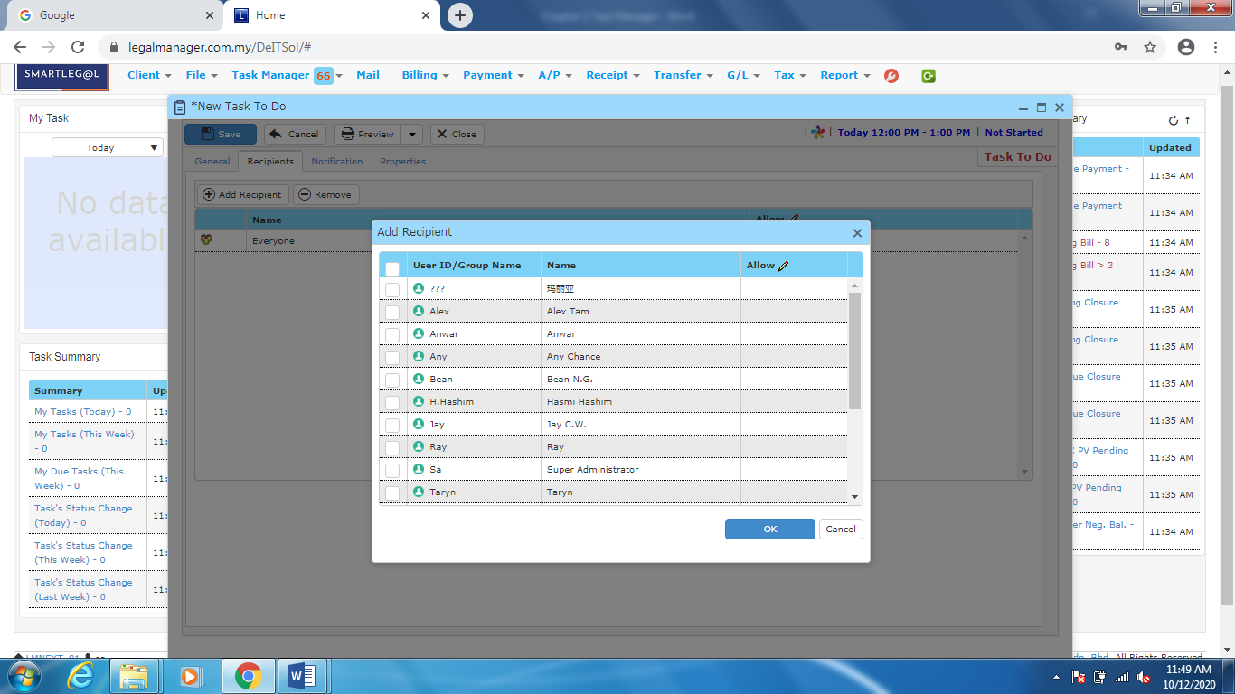

Figure: New Task To Do – Recipient, Add Recipient

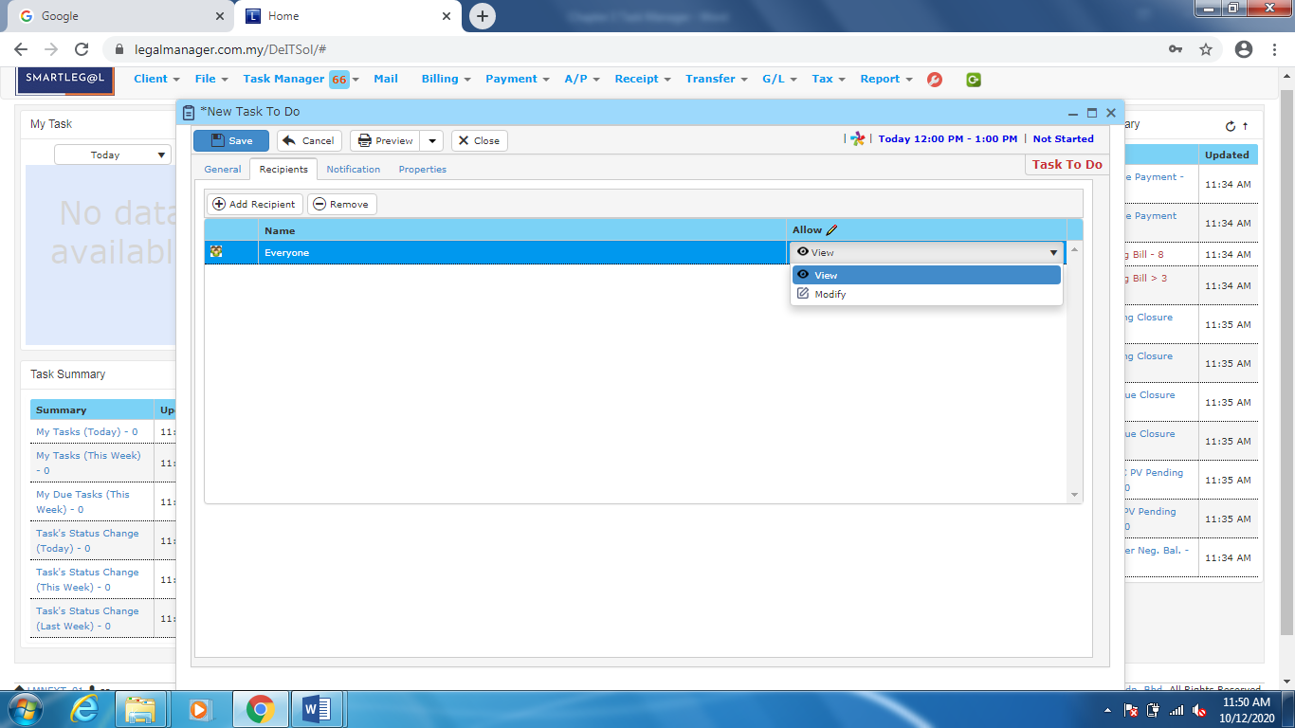

Figure: New Task To Do – Recipient, View/Modify

* + You can Add, Add a Copy, Edit and Remove Notification of Task

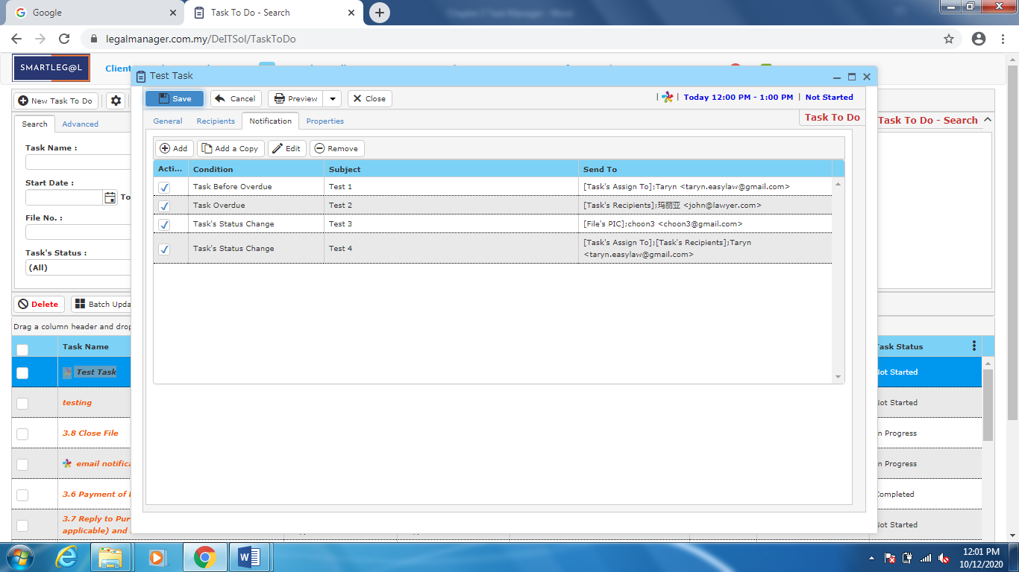

Figure: New Task To Do – Notification

* + You have to select a condition before adding a new notification

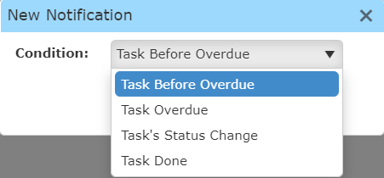

There are few conditions for the notification as figure above shown:

1. Task Before Overdue - System will send mail to remind recipient before the task assigned overdue, the time to sent the mail before task overdue can set by user.
2. Task Overdue - As simple as the condition mention, the system will send mail to tell recipient that the task assigned already overdue
3. Task’s Status Change – System will inform recipient once the task’s status amended
4. Task Done – System will send mail to related recipient when the task completed

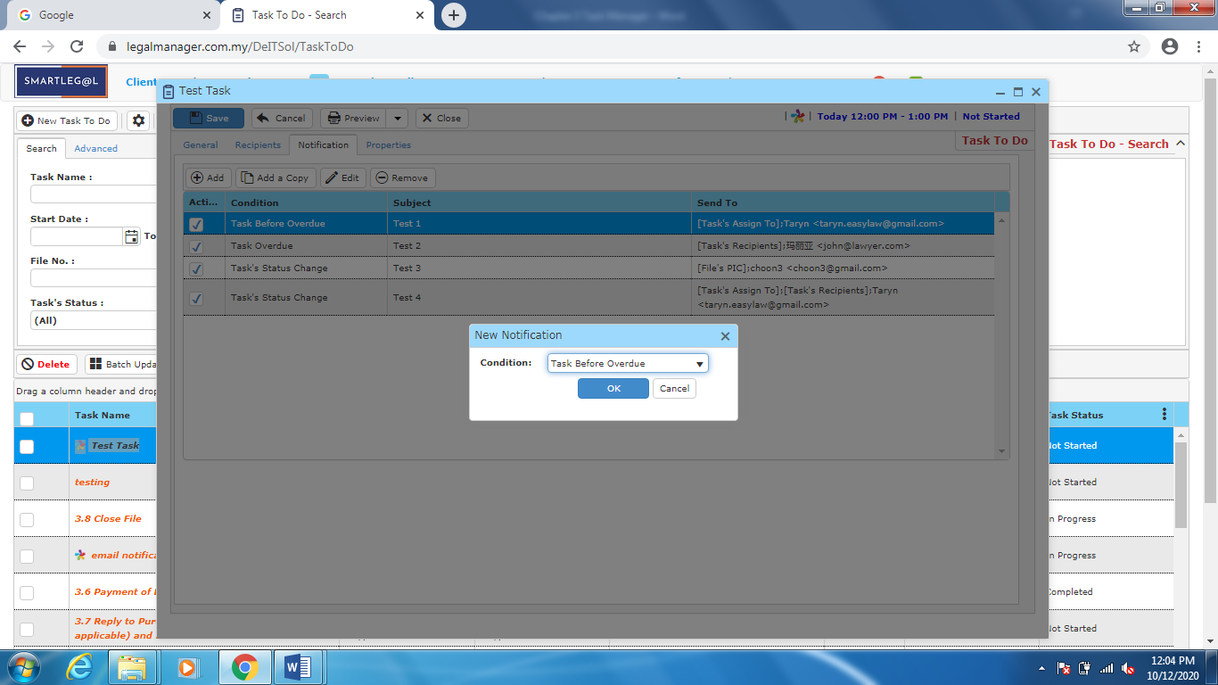

Figure: New Task To Do – Notification - Add Notification, Condition

* + Fill in new notification details

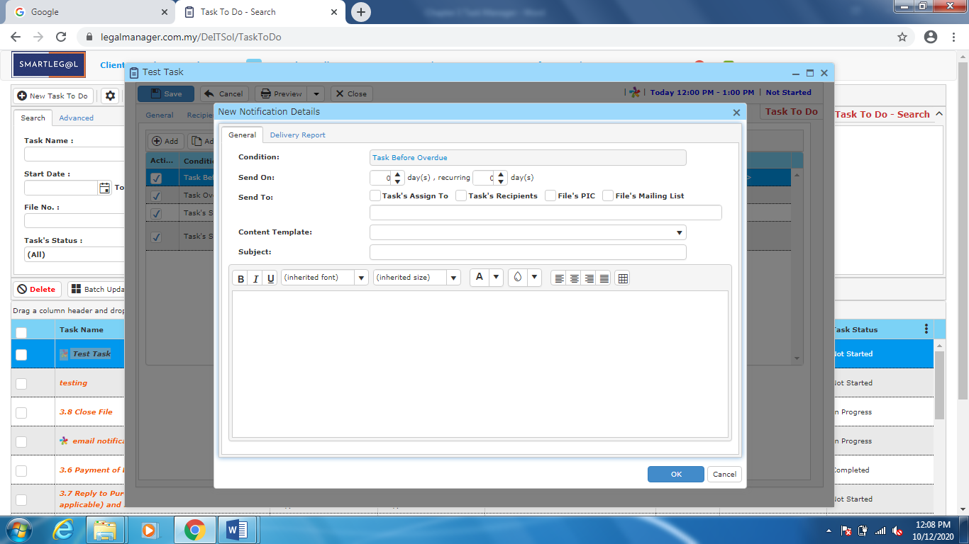

Figure: New Task To Do – Notification – Add Notification, New Notification Details

* You can view the information of the task once who modify the supplier then there will show the last modified and modified by who
* Once you finish all the instruction above, click ‘Save’ then you are done to create a new task.

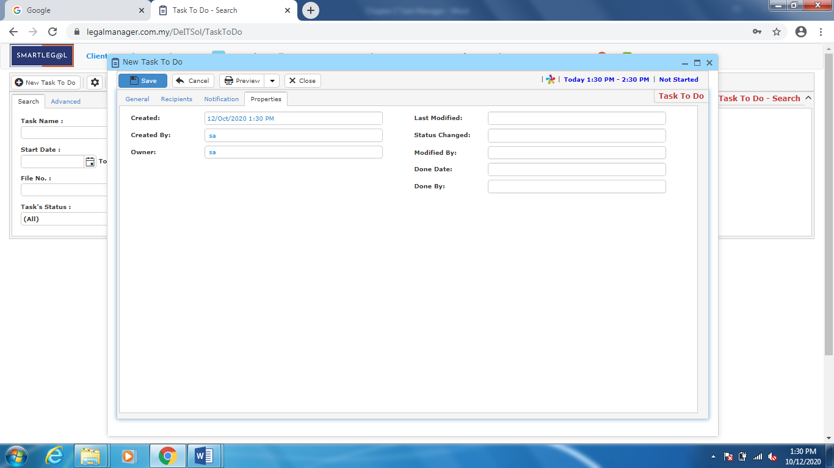

Figure: New Task To Do – Properties

**3.3 Manage Task To-Do**

This option enables you to add, edit, and delete a task. It also allows you to keep track of task details and all related information.

* To open Manage Task To-Do, on the **SmartLeg@l** navigation, click **Task Manager** and go to **Manage Task To-Do** then search the task you wish to modify.

**Manage Task To-Do**

* Search the task you wish to manage through type the search criteria or search by advanced.
* To start a new search or to clear the search results, click ‘**Clear**’.

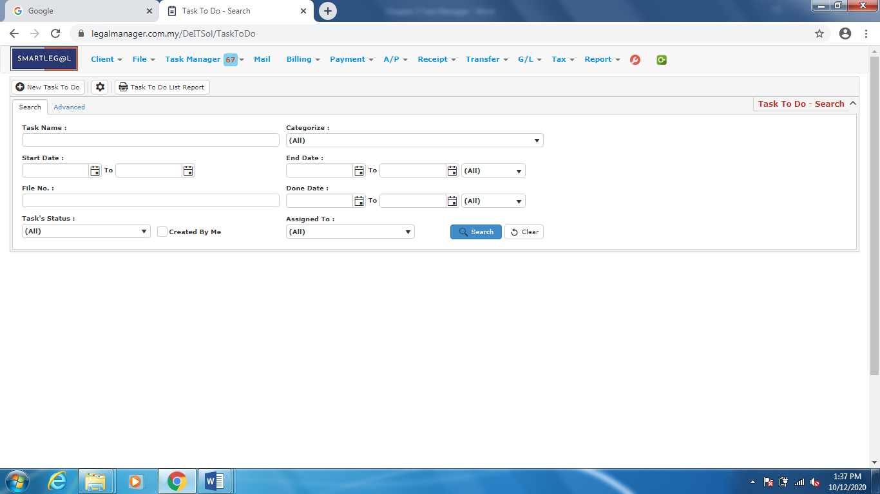

Figure: Manage Task To Do – Search

**Advanced Search**

* This function can be used to find a task by searching other information that is not captured in the ‘General’ section.
* Define search criteria:

**- Field** - Choose the field you want to search.

**- Condition** - Search condition

**- Value** - Type in the detail you want to find.

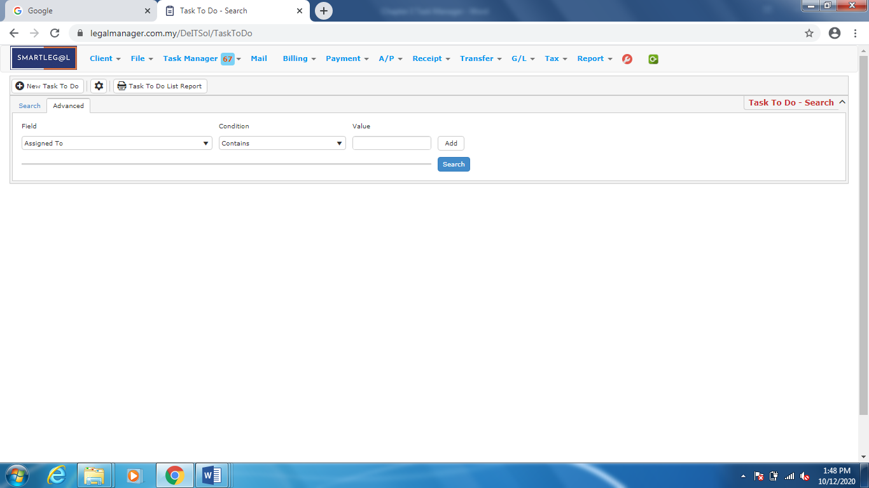

Figure: Manage Task To Do – Advanced Search

**Searched Result**

* Click ‘**Search**’ once, to show all Tasks
* The Searched result will appeal at below, otherwise it will shown no record availble if the file you searched do not exist.

Click ‘**Export**’ to print the desired search results in txt, excel or html format.

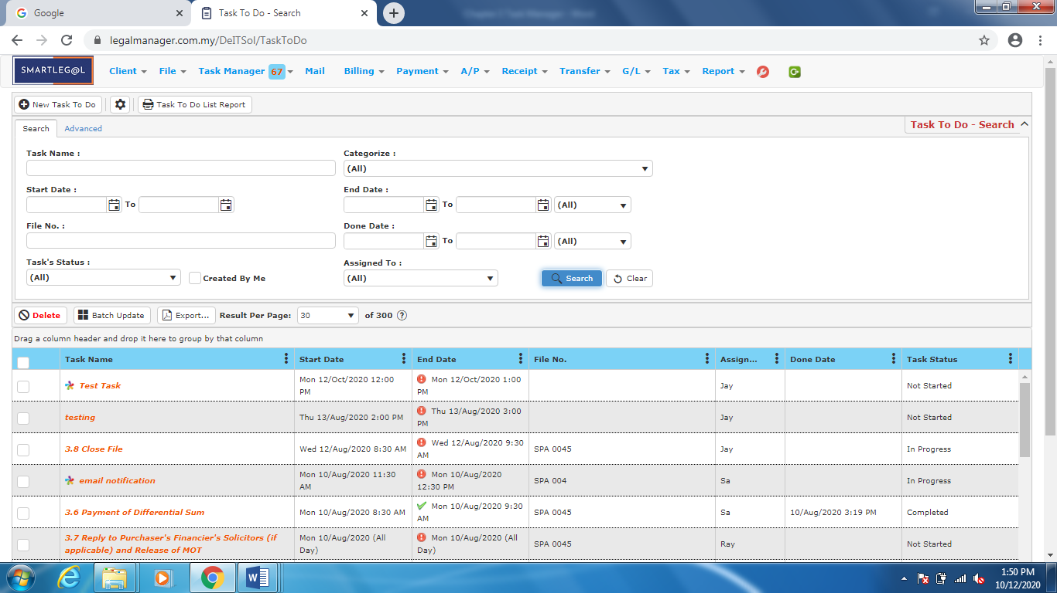

Figure: Manage Task To Do – Search All Tasks

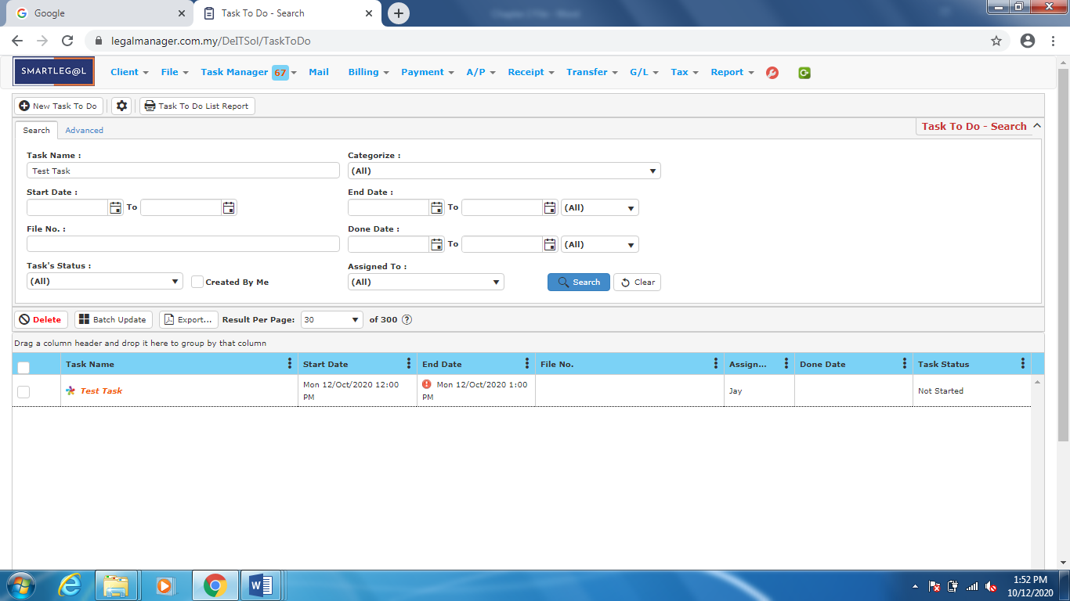

Figure: Manage Task To Do – Search Result

* After the task your search result appeared, you can choose to view and manage to edit those details by double-clicking the record.

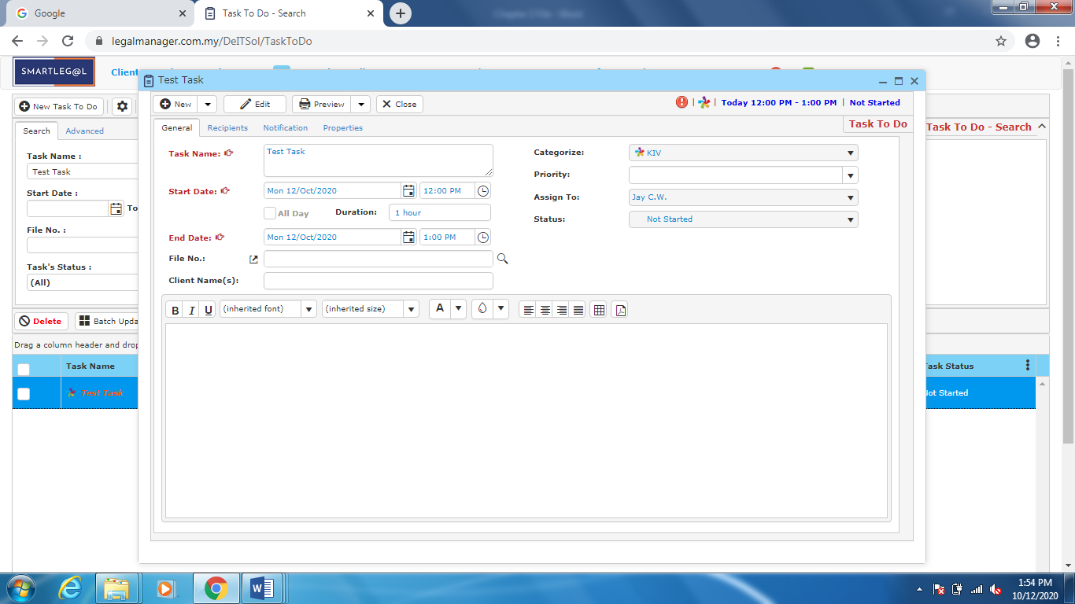

Figure: Manage Task To Do – Search Result, Task Info

**3.4 New Court Matter**

You can create court matter and reference them to file. You can also copy court matter to task. Retrieval of the court matter from the menu bar is easy.

* To open New Court Matter, on the **SmartLeg@l** navigation, click **Task Manager** and go to **New Court Matter** then click the tab you want to type in information.

- You can open court matter input form by clicking.

- Court Matter form will show up as shown in ‘*Figure: New Court Matter General Input’* below.

- In the Task Name box, type a task name.

- Complete any other necessary information.

- Click ‘**Save**’.

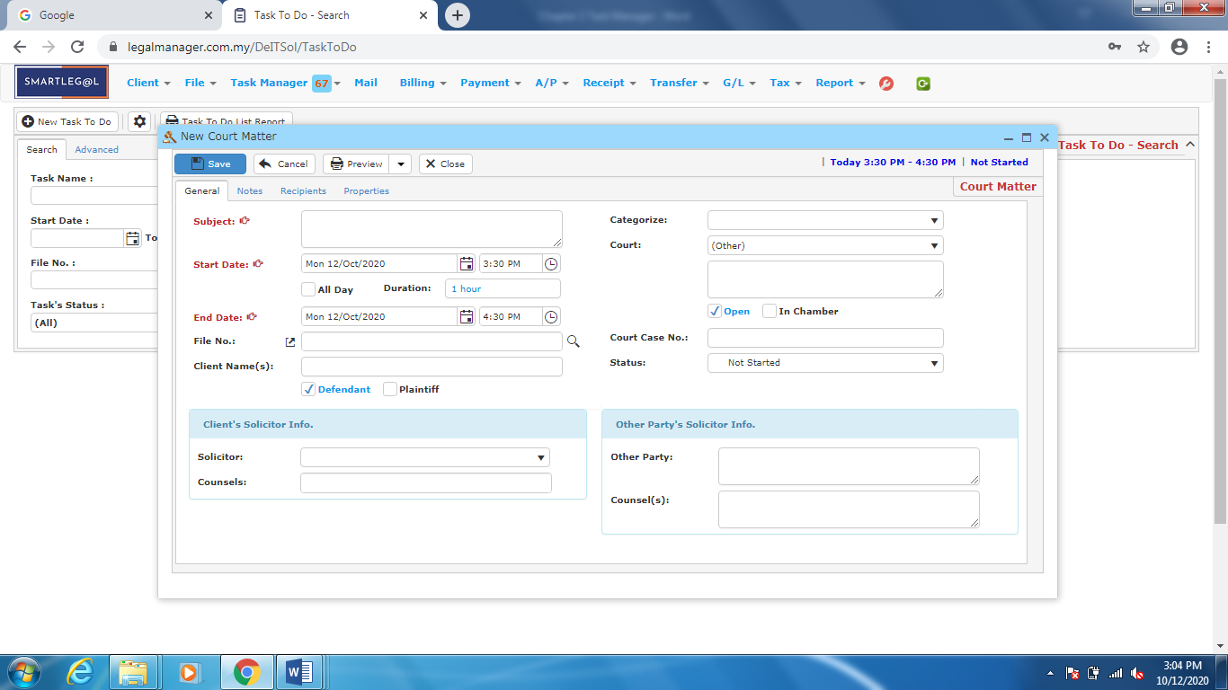

Figure: New Court Matter General Input

* You can add some note in this court matter as a reminder

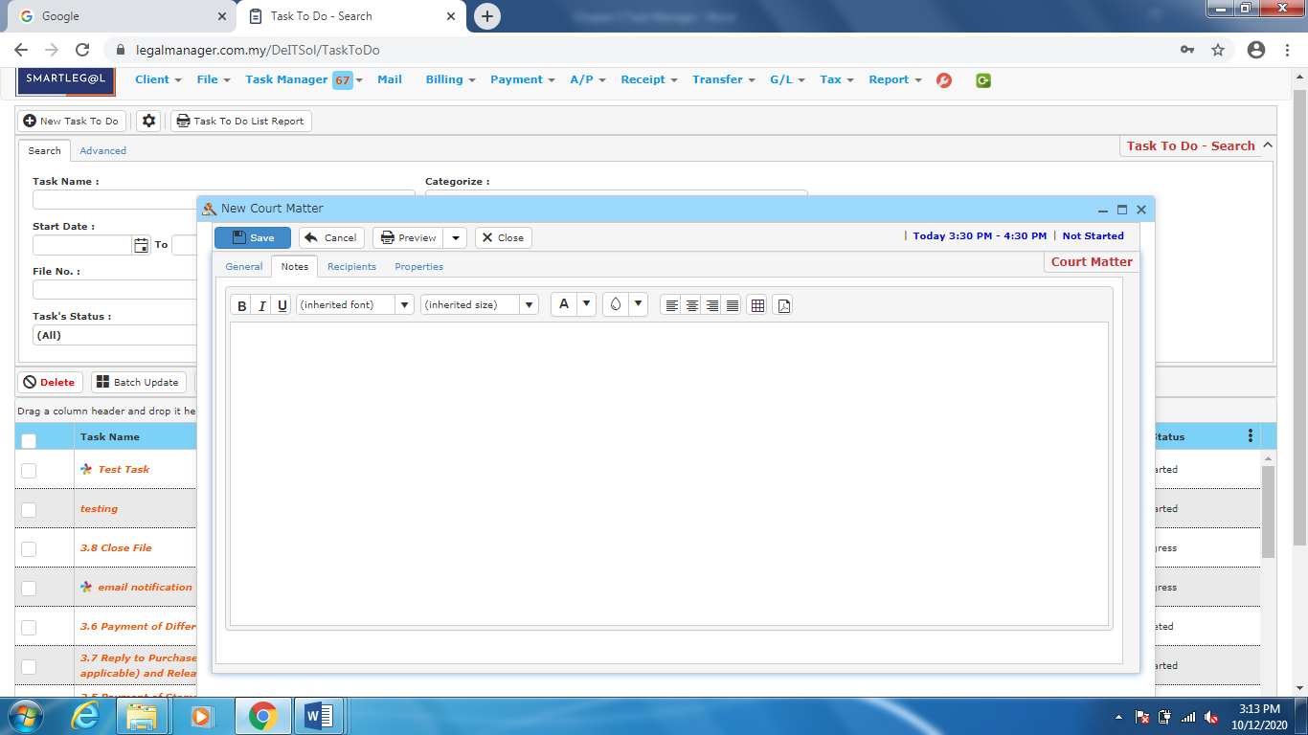

Figure: New Court Matter - Note

Note: Function of Recipients and Properties in New Court Matter is exactly same in **3.2 New Task To Do**.

**3.5 Manage Court Matter**

This option enables you to add, edit, and delete a court matter. It also allows you to keep track of court matter details and all related information.

* To open Manage Court Matter, on the **SmartLeg@l** navigation, click **Task Manager** and go to **Manage Court Matter** then search the court matter you wish to modify.

**Manage Court Matter**

* Search the court matter you wish to manage through type the search criteria.
* To start a new search or to clear the search results, click ‘**Clear**’.

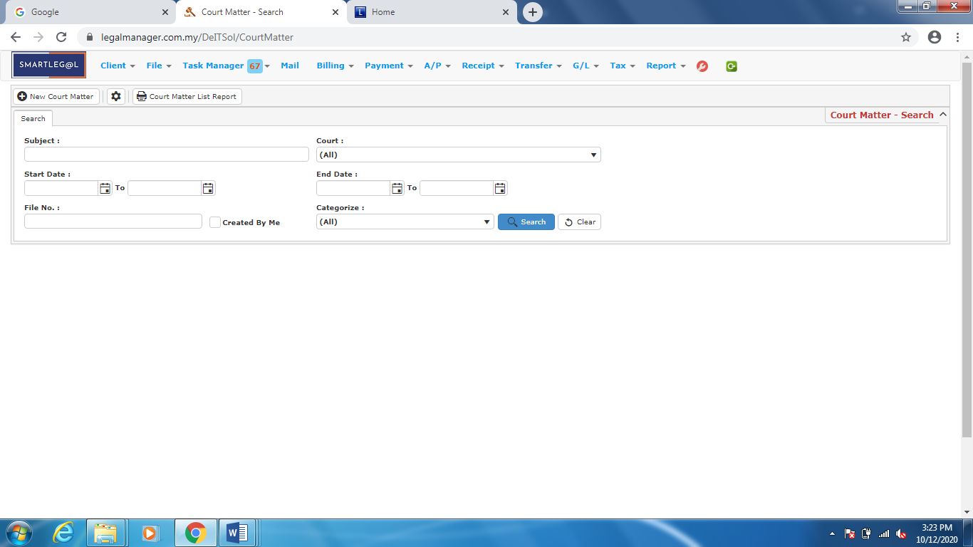

Figure: Manage Court Matter – Search

**Searched Result**

* Click ‘**Search**’ once, to show all Court Matters
* The Searched result will appeal at below, otherwise it will shown no record availble if the client you searched do not exist.
* Click ‘**Delete**’ to delete the selected record.
* Click ‘**Export**’ to print the desired search results in txt, excel or html format.
* Click ‘**Download(Zip)**’ to download the zipped document.

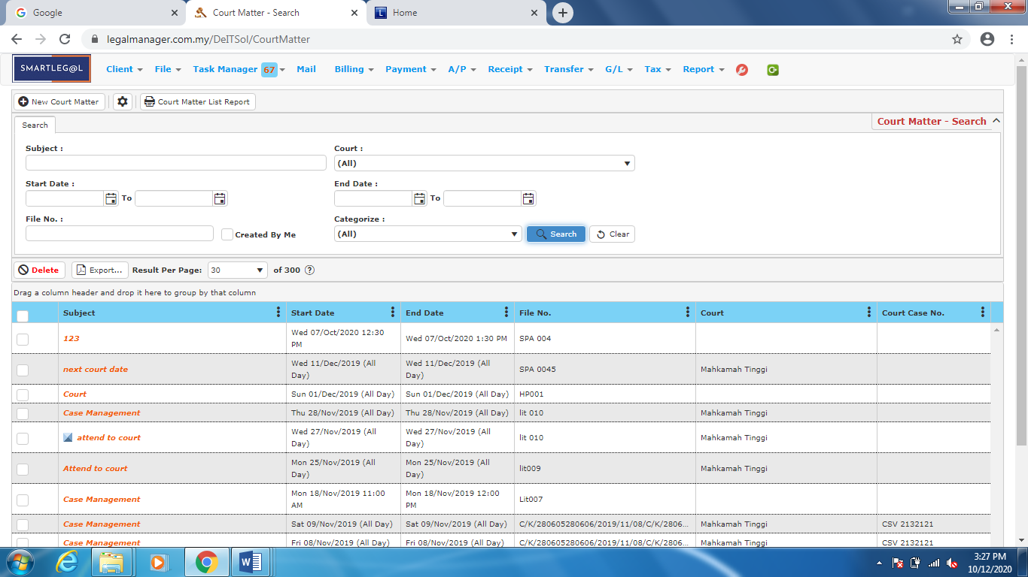

Figure: Manage Court Matter – Search All Court Matters

* After the court matter you searched appeal, you can choose to edit or preview the court matter.

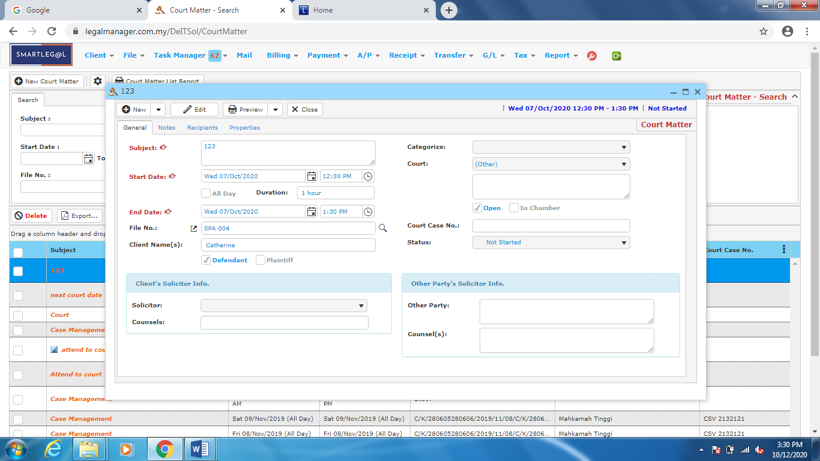

Figure: Manage Court Matter – Search Result, Court Matter Info

**3.6 New Appointment**

Users can create appointment and reference them to file and give permission to schedule or make changes to appointments in their calendars.

* To open New Appointment, on the **SmartLeg@l** navigation, click **Task Manager** and go to **New Appointment** then click the tab you want to type in information.

- You can open court matter input form by clicking.

- Court Matter form will show up as shown in ‘*Figure: New Appointment General Input’* below.

- In the Task Name box, type a task name.

- Complete any other necessary information.

- Click ‘**Save**’.

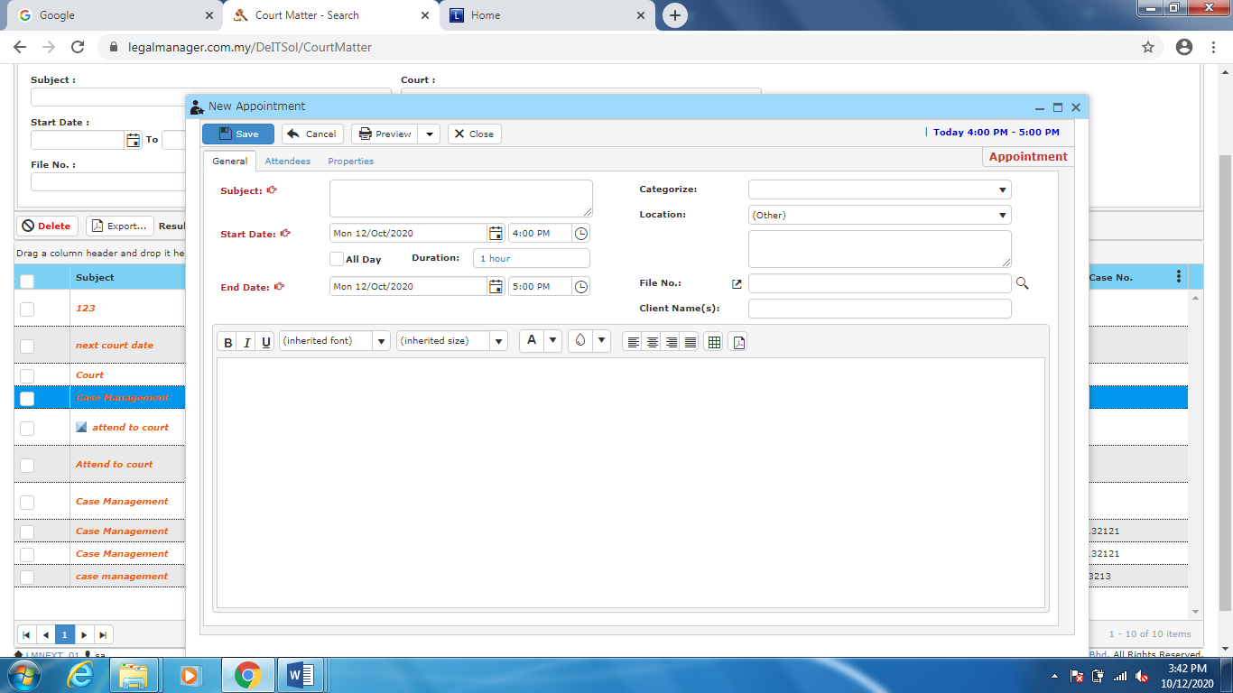

Figure: New Appointment General Input

* + You can Add or Remove Attendees as ‘Figure: New Appointment – Attendee, Add Attendees’
  + You can also choose to allow attendees to view, invite or modify

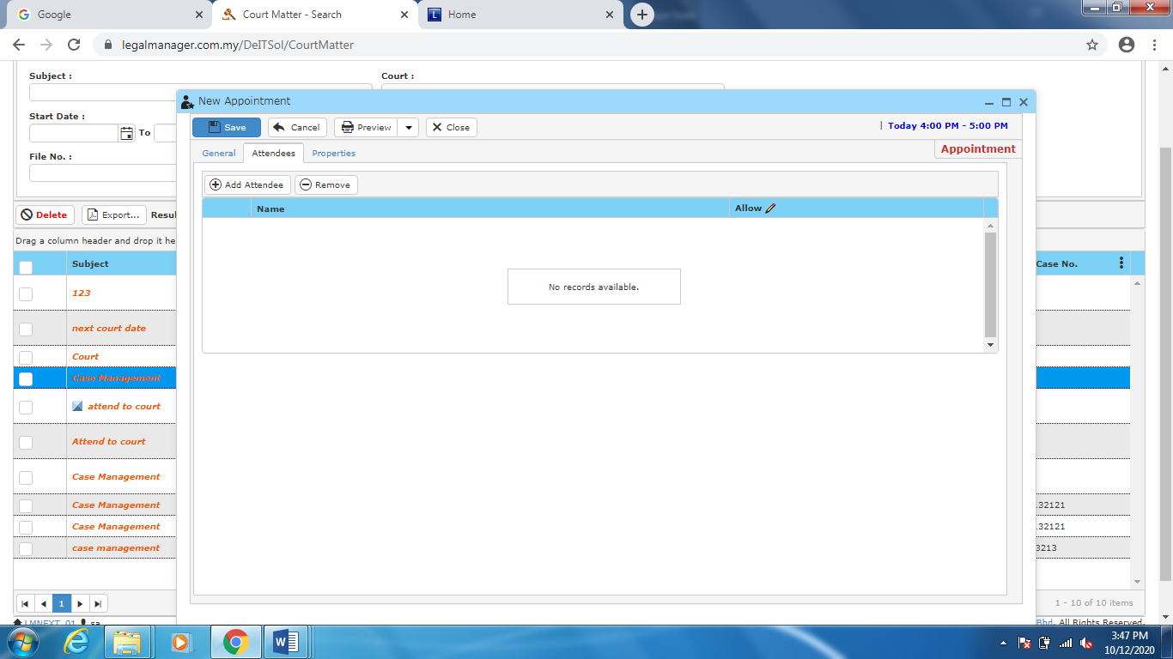

Figure: New Appointment –Attendees

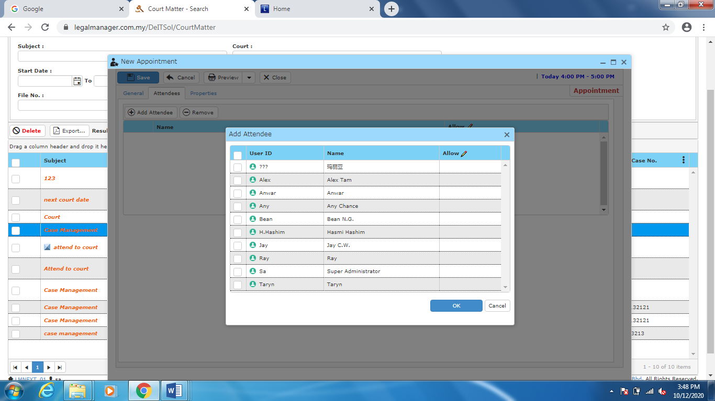

Figure: New Appointment – Attendees, Add Attendees

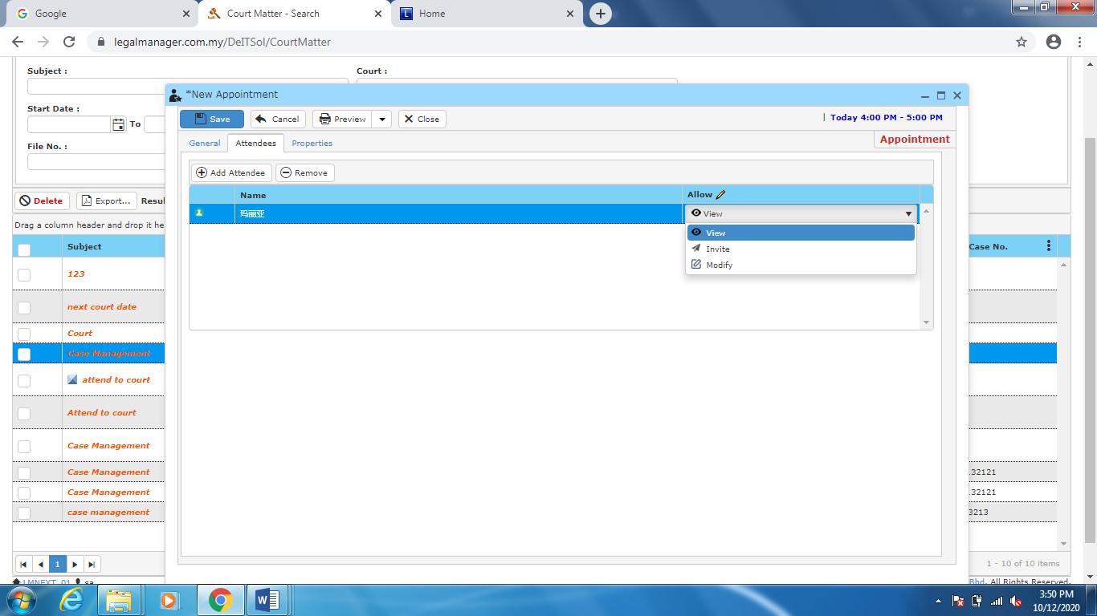

Figure: New Appointment –Attendees, View/Invite/Modify

* + You can choose to allow attendees to view, invite or modify by selecting from the combo box

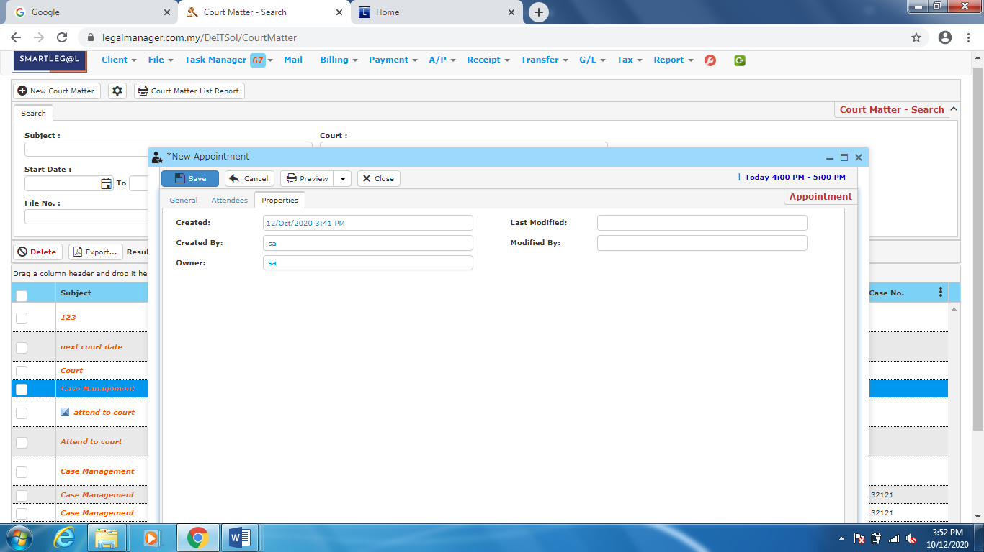

Figure: New Appointment – Properties

**3.7 Manage Appointment**

This option enables you to add, edit, and delete a appointment. It also allows you to keep track of appointment details and all related information.

* To open Manage Appointment, on the **SmartLeg@l** navigation, click **Task Manager** and go to **Manage Appointment** then search the court matter you wish to modify.

**Manage Appointment**

* Search the appointment you wish to manage through type the search criteria.
* To start a new search or to clear the search results, click ‘**Clear**’.

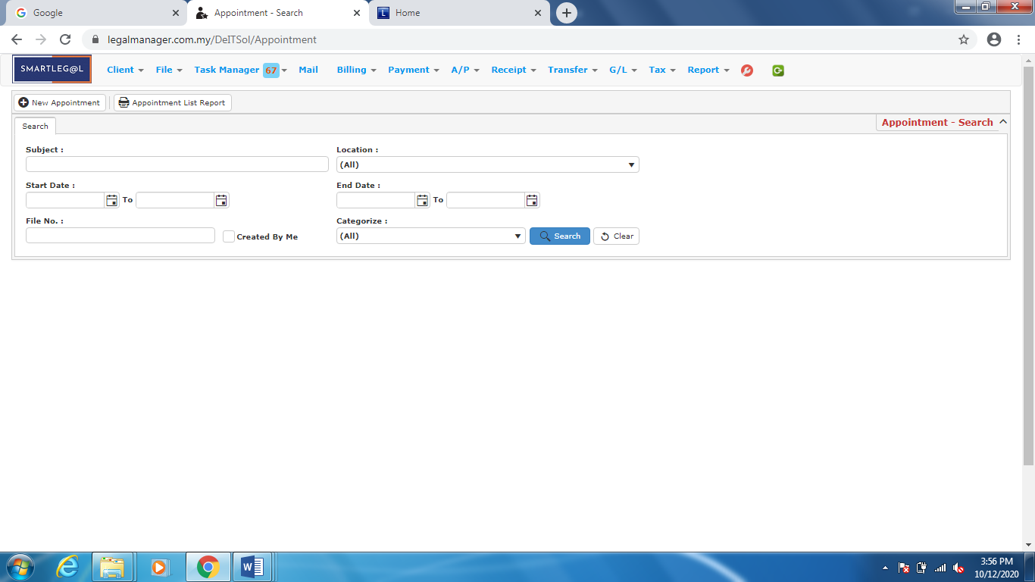

Figure: Manage Appointment – Search

**Searched Result**

* Click ‘**Search**’ once, to show all appointment
* The Searched result will appeal at below, otherwise it will shown no record availble if the client you searched do not exist.
* Click ‘**Delete**’ to delete the selected record.
* Click ‘**Export**’ to print the desired search results in txt, excel or html format.
* Click ‘**Download(Zip)**’ to download the zipped document.

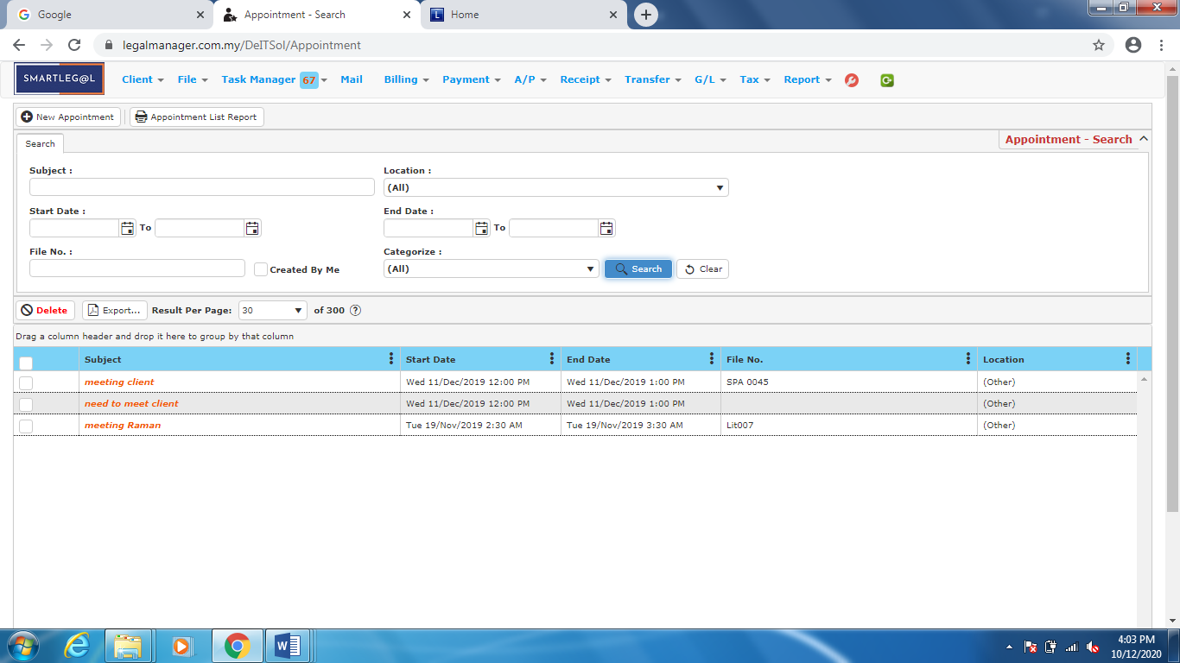

Figure: Manage Appointment – Search All Appointment

* After the appointment you searched appeal, you can choose to edit or preview the appointment.

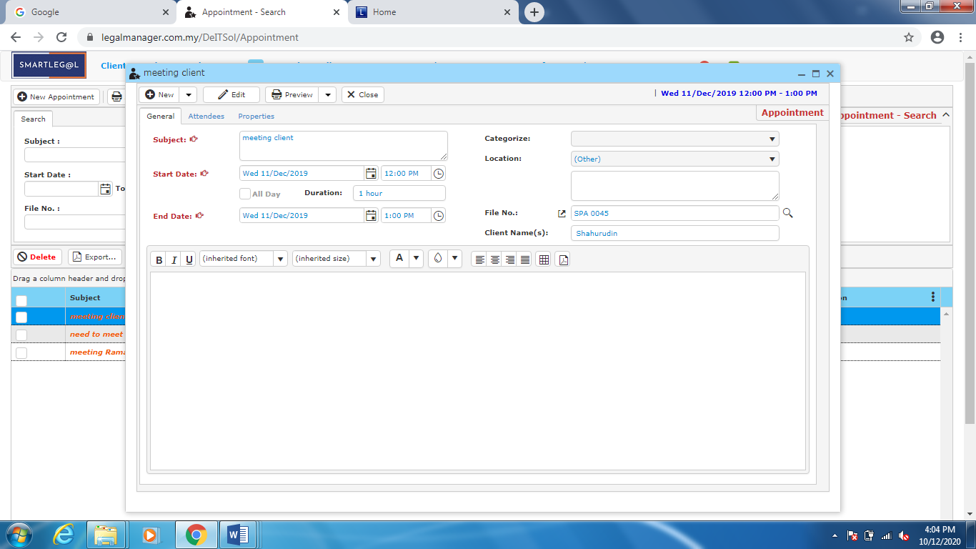

Figure: Manage Appointment – Search Result, Appointment Info

**3.8 Reminder List**

This option reminding you to view tasks.

* To open Reminder List, on the **SmartLeg@l** navigation, click **Task Manager** and go to **Reminder Lis**.
* You can view selected task by double clicking on the reminder list.

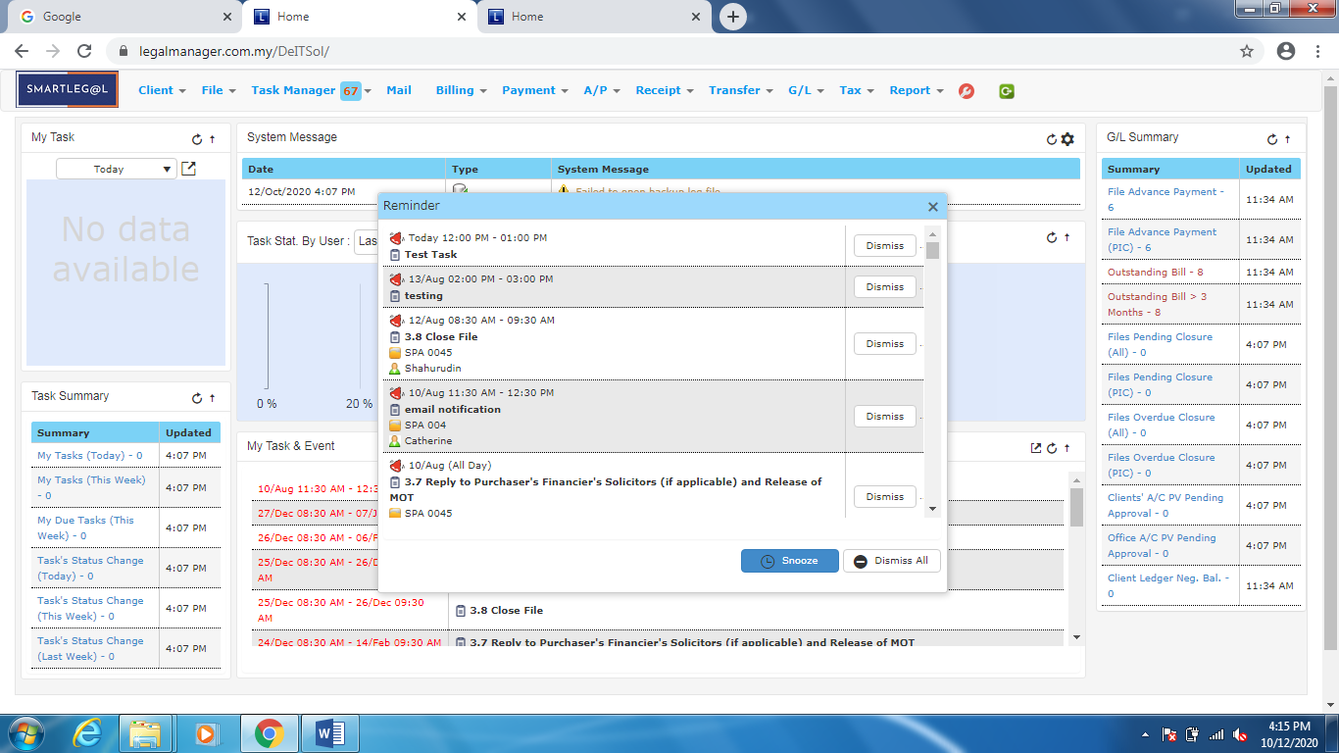

Figure: Reminder List